1.) Our personas or imagined users for the Covid-19 hotspot detector product would be for that average citizen of any country. Our biggest issues today are that people do not have enough information for infected areas before traveling and with our proposed idea, it would help solve this issue.

2.) Other stakeholders of the project could include restaurants, schools, and other essential businesses since their main profits and ability to stay in business is dependent on how critical the outbreak in their area is.

Map:

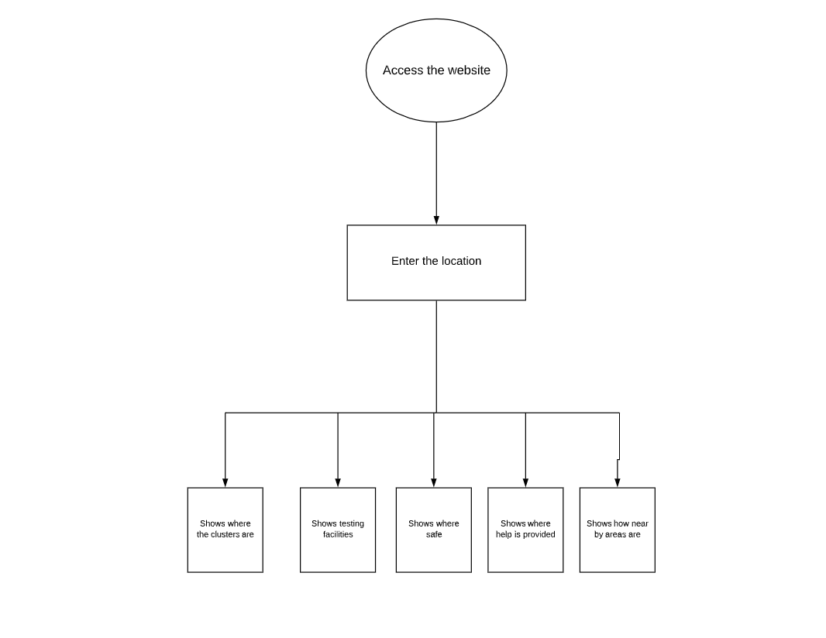

Scenarios:

Users will be provided with data that includes where Covid Clusters are in their location. The data would also include nearby testing facilities which will help the local public to know where to get tested and also what areas to avoid. It will also give them an idea of how safe their nearby areas are as well.

User Stories:

Jay recently came in contact with a Covid-19 infected person and he wants to see where the nearest testing facility is and the website helps him find the closest one.

Feature list:

Convenience tracking

Contact tracing